How to sign up a member using the new Digital Union Card
A step-by-step walkthrough you can use in the break room, at a member’s door, or while tabling.
Takes about 3 minutes per person — no app to download.

Open the card
unioncard.netlify.app
Works in any phone browser — Safari, Chrome, whatever they already have.
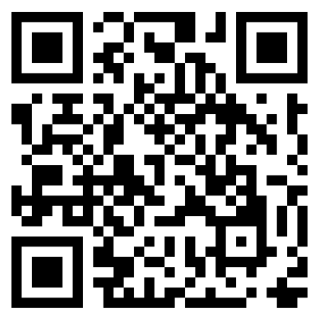
Have the member scan the QR code or type the address.

What the member will see
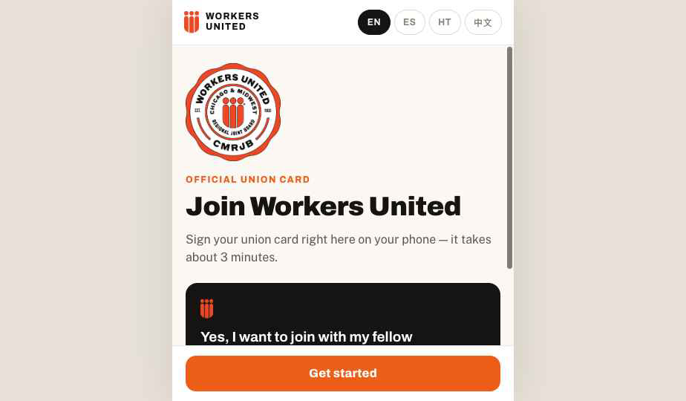  1. Welcome screen | 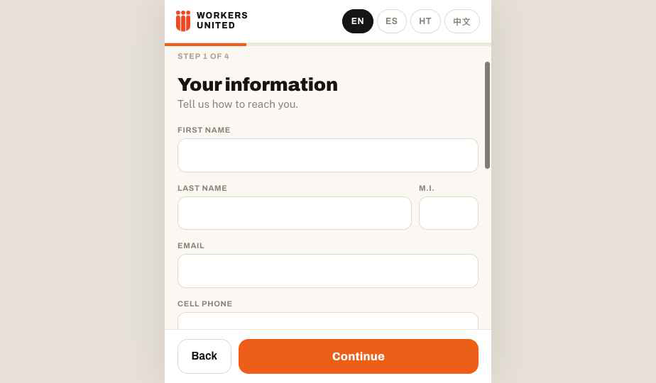  2. Their information
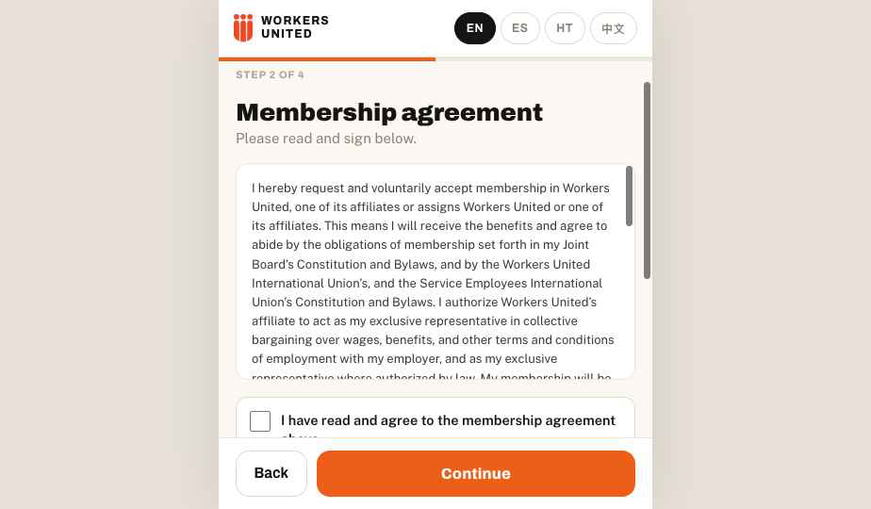  3. Membership agreement + signature | 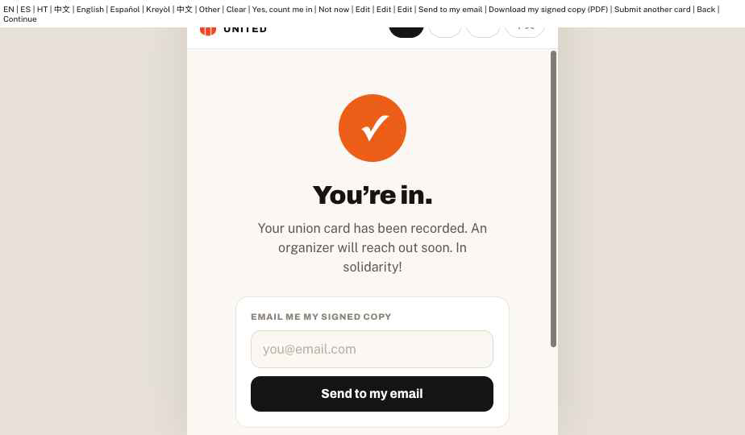  4. Confirmation

Tips for teaching others
- Let them hold the phone and tap through it themselves — people trust it more when they sign it.
- If English isn’t their first language, switch to their language first (top-right) — the whole form and agreement translate.
- No worksite listed? Then do not have your member fill out this card. Continue to use the paper card for now.
- No signal? The form works offline until they hit Submit — have them submit once they’re back on WiFi or data.
- They can request their own signed copy by email on the confirmation screen — totally optional, doesn’t affect their card.

What happens after they submit
- Their signed card (with signature) is emailed automatically to our dues team, the rep for their worksite, and the new member — that’s the official record.
- A Union Rep or Shop Steward will contact the new member directly.
- Nothing more for you to do — no paper, no scanning, no mailing.

